Section I – Introduction

Welcome. This tutorial will teach you how to edit the Tiberian Sun executable – exe – file, as well as the Language.dll file.

Firstly, before anybody gets too exited I must say that the things you can do with this tutorial are limited. What is here is pretty much all you can really do, without knowledge far beyond the skill of most in the TS modding community.
You cannot add or delete code, override “hard coded” things or change the way the game works in any way. You can only replace certain file names that TS searches for and rename/replace certain things.

The programs I am using in this tutorial are Resource Hacker and HHD Hex Editor. Both are 100% free and are easy to find using search engines. You can use other programs if you wish, but it may not be as easy to follow the tutorial with them.

I have tried to make this as Idiot-proof as possible, but this is my first tutorial, and I know some can mess up the simplest things. If you have any questions please ask and I/someone friendly will help you.

So, with that we begin…

Section II – Editing the TS .exe with a hex editor

Clone the file GAME.EXE (Not SUN.EXE!), and rename it to whatever you want. This is your Mod’s new exe. Open this new file with your hex editor and you will see something like this:

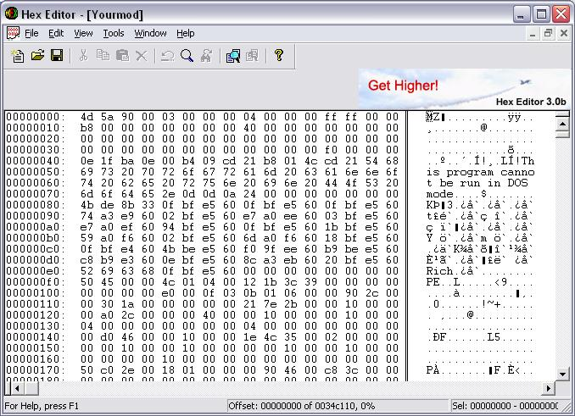

As you can see, it’s a load of numbers and letters. The only legible part is “This program cannot be run in DOS mode”, which is true, but not useful. The only parts we can edit are the legible parts, which I will tell you how to find.

From here we start editing.

Changing the ecache##.mix/expand##.mix file names:

Click “find” up at the top. Search for “ecache”

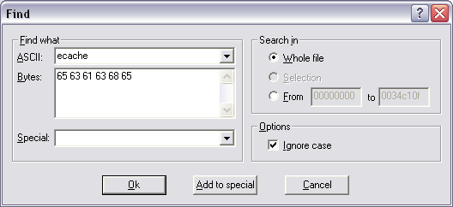

Note that the “bytes” section fills automatically. Make sure “Ignore case” Is checked.

Pres OK. You will notice that this takes you down the file to here:

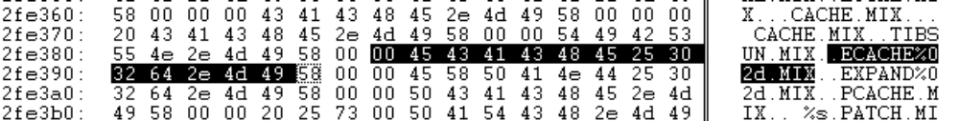

You can now change this to any 6 letter word you want. Let’s use pigeon.
You do not have to use capitals – the game will accept uppercase and lowercase. It will even accept certain symbols, but be careful when using them.
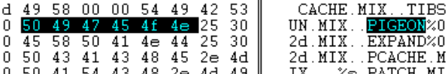

The numbers and letters in the left column will change automatically.

And there we go. Press save, and the game will no longer read from ecache##.mix files. It will read from pigeon##.mix files instead.

Note you cannot change the %02d bit without the game glitching.
Changing the file extension will not have any affect.

Now for expand##.mix. Do the same, search for all references to “expand” and replace them with your desired name. There are 3 references to “expand”. Change them all. And there we go. Can you see a pattern emerging?

Other mix files:

It is possible to change them too, but being honest there is little point. But you can if you want. It’s the same procedure – find and replace.

.ini files – the same old routine…:

Yep, you guessed it. Find and replace. You will find a reference to RULE*.ini and RULES.ini Just Put URRU*.ini and URRUES.ini respectively. Note the names can be anything, as long as it’s no longer than the current value.
All the .ini file names can be changed to whatever you want.

Language.dll:
This is particularly handy if you plan on editing it (See section III). Search for “Language” change references to language.dll to anything you want, Just like before:
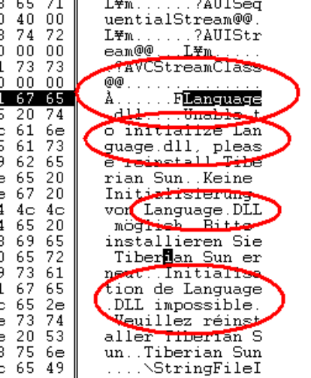
Do not change the “F” prefix in the highlighted one, or it won’t work.

Other file types:
It is possible to edit the other files that TS uses, palette file names (see pictutre), debug file name, loading screen PCX’s, screenshot file names and more.
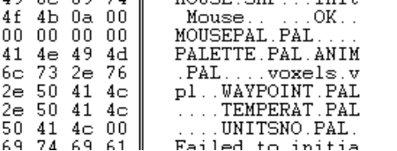

Drop-Pod Infantry:
There are many ways to make the infantry in drop-pods different from the standard E1 and E2. This is done so you can drop in “special” units, only available in this way. The most common method I have seen used is to make
E1 and E2 unbuildable, then make new Light Infantry and Disc Thrower units.
Though this works, it has its problems. Missions with scripted events using E1 and E2 will be messed up, and the AI needs to be told to build the new Light infantry units/Disc thrower unit, rather than E1 and E2 – Something difficult if you can’t edit AI.ini very well.

Anyway, enough harping on… How it this done?

It’s much like before actually. BUT searching for E1 or E2 will get you a lot of results, most of which have nothing to do with drop-pods. So, we search for something related to drop pods. Superweapon? Name one. Multimissile?

Search for “MultiMissile” or “SuperWeapon”. You will get something like this:
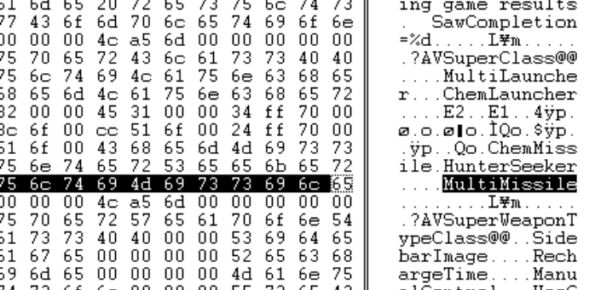

Now, look four lines above it. See something familiar? That’s right - E1 and E2.
You can change these to any two letter word you want. Then save and make an entry for them in rules.ini/art.ini. It’s as simple as that.

Changing the text and colours in the “select colour” menu (I):
Okay, something more complicated. Let’s say you want to make a new side colour – replacing sky blue (as there are two “blue” colours) with say, brown. Note that this only changes the colour name and colour in the menu, not in game. To do that you have to make rules.ini modifications, which I will not cover here. Say we want…brown. This needs both exe and .dll editing for it to work.

Click “find” and get the box to match the settings/have similar settings to the one below:
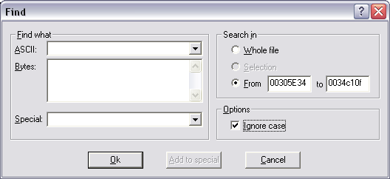
Then press OK. This forces the editor to search fro anything from 00305E34 to the end of the exe. For those of you who are wondering, 00305E34 is something called an Offset. Think of it as the HEX equivalent of a grid reference. Each “byte” or section of data (normally consisting of two letters or numbers) has a unique Offset.

Anyway, once you reach offset 00305E34 you will see something like this:
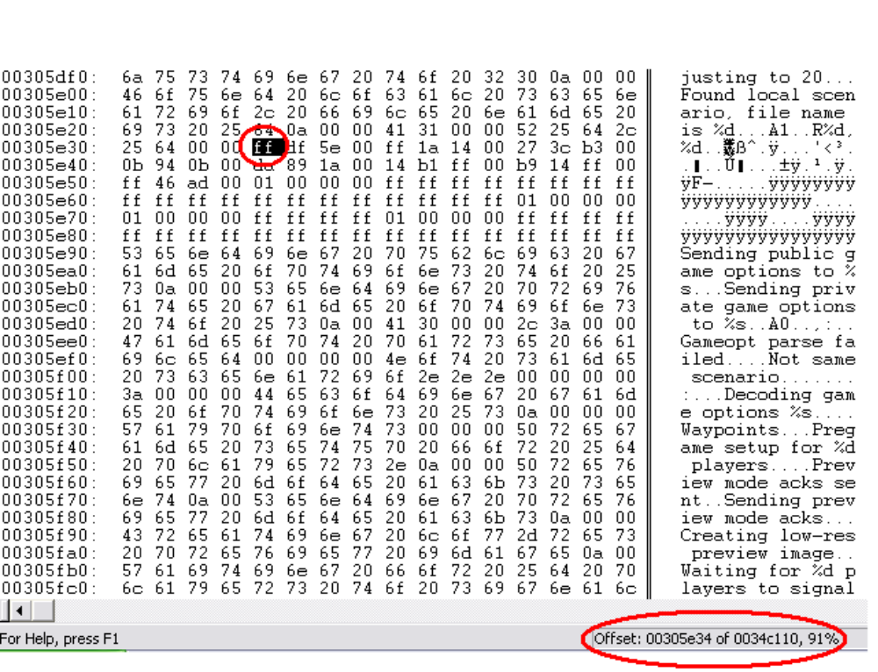
The two circled letters represent one byte. The circled bit at the bottom shows the offset, total/max offset and percentage through the exe you are located at.

There are two more bytes there (to the left), after the ff – df and 5e. Put ffdf5e into a program (I use Photoshop)/webpage (find one using a search engine) that can translate HEX colours and you get:
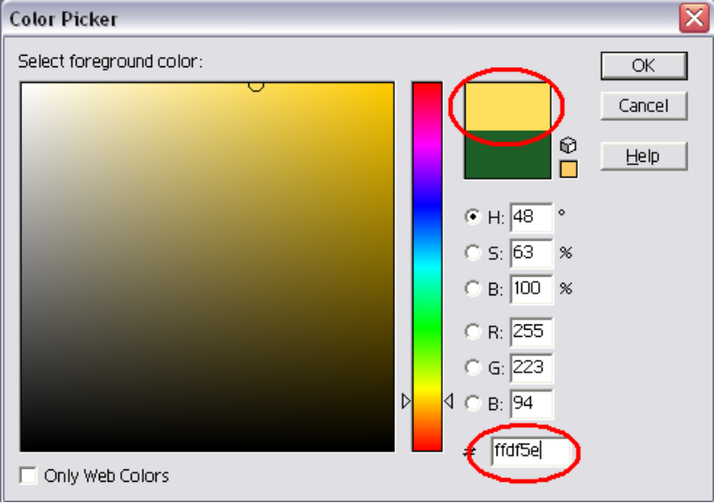
That’s right, gold. And what’s the first colour on the list? Gold!
Then comes two zero’s (00). Then another 3 bytes – ff 1a 14. This is the next colour – red.
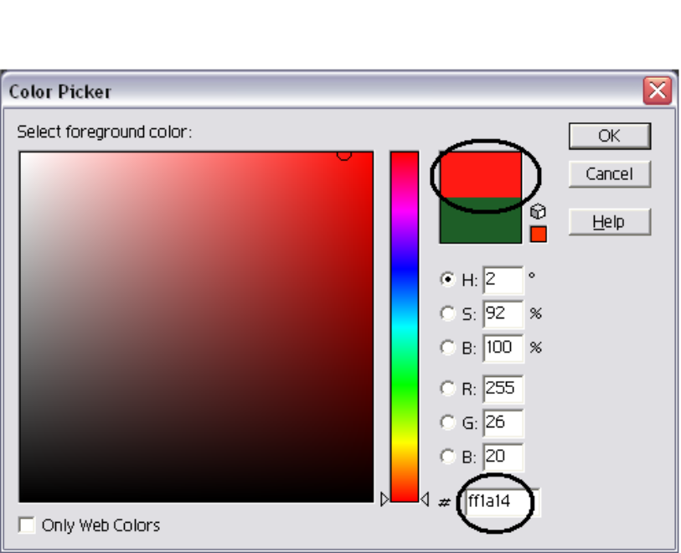
And so on and so forth. Here is a screenie, showing the locations of all the colours, colour coded naturally:
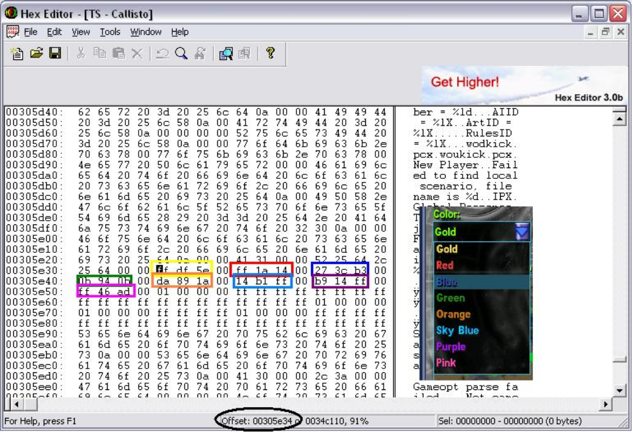
So, to change sky blue we change the 3 bytes 14 b1 and ff to a brown colour – we can find the new code for that in our program/webpage:
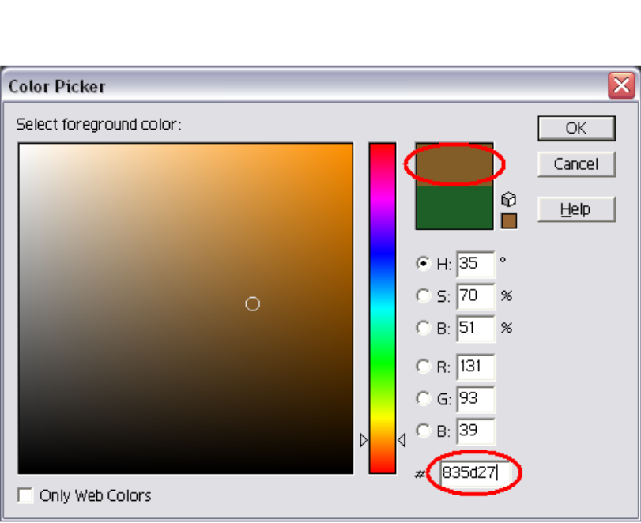

Put 83 5d 27 in:
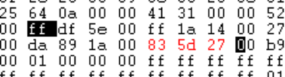
Then start up TS and:
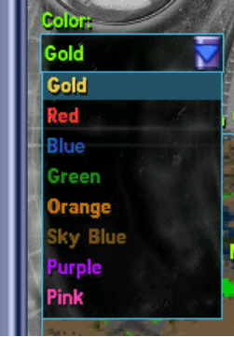
There we go! Now the text colour is brown, to match your new side colour. But there is one flaw – The words still say “Sky Blue” – Not “Brown” as they should.

To change this we need to edit Language.dll, which is further down. So scroll down until you find part II of this, under “Editing language.dll with resource hacker”.

Interesting Note:
It is possible to see all the “tags” used by TS in the hex editor. Just search for a known one – say, “WallOwner” and there it is, surrounded by many more, including a few un-documented ones.
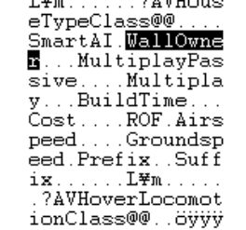
You can also see all the command line options (search for”–MPDEBUG” or similar). Although SMIFFGIG got those ages ago and told us what they did, it’s interesting to see where he got them from.

Section III – Editing Language.dll with Resource Hacker

This will take you over some basic things that can be done with resource hacker. There are many more things you can do, but they are more difficult to explain in a tutorial, and are best found out by experimenting yourself.

Clone Language.dll and (if you set it to read something else in the exe) name it to that filename. If not, call it anything. Rename the original to OldLanguage.dll or something, and then change the clone to Language.dll. Open the clone.

“Dialog”:

You will see 4 folders:
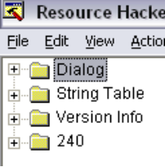

Each contains various things to do with the game. Open “Dialog”. More folders will appear. These contain all the “Dialog” boxes that appear in game. So, say we wanted to add the words “Pigeon Pie” to the sound options box (Its only an example ok!) then you search through all the files until you get to the right one (number 184 in this case) and open it. You will get something like this:
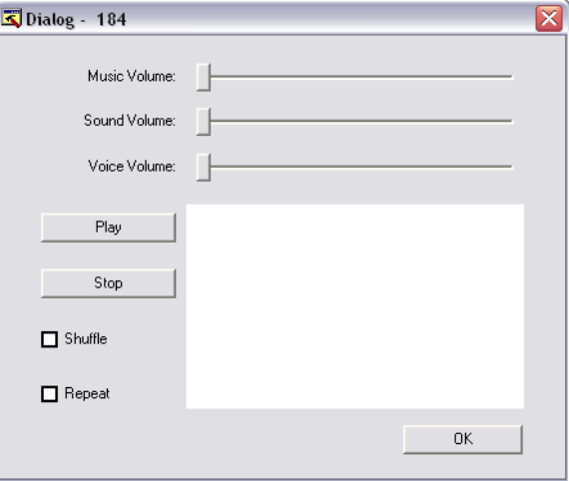
Don’t worry about the white/blank space, the game can read it fine.
There will also be a load of code in the background, but we can ignore that for now.

Right click the dialog box and press “Inset control”. Now press (in the box that appears) the circled box below. Then type in whatever you want to type under “Caption”:
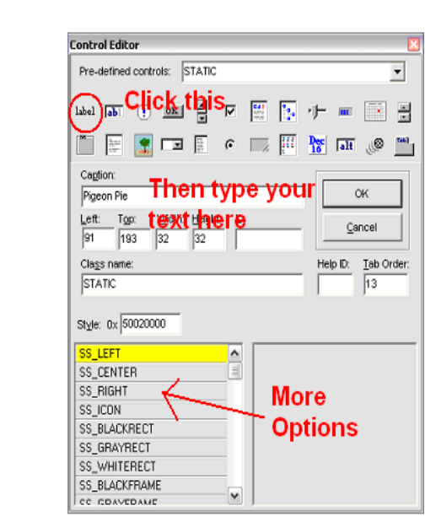

The “style” area can be used to put boxes around the text, centre it and more.

Press “OK”. You should get:
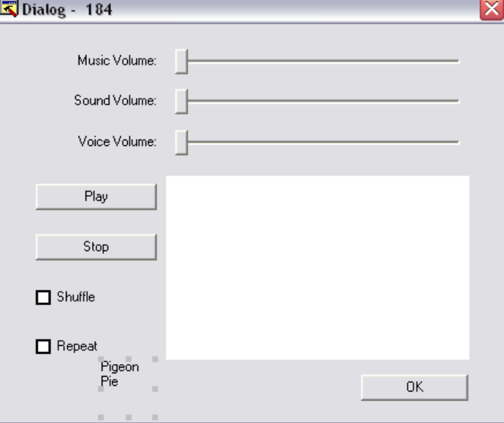

Use the corner tabs to place/resize your text then press “Compile Script” up at the top. And there we are. Save the file, and start TS to test. It should work. If it looks wrong, go back and move it around until it looks right.
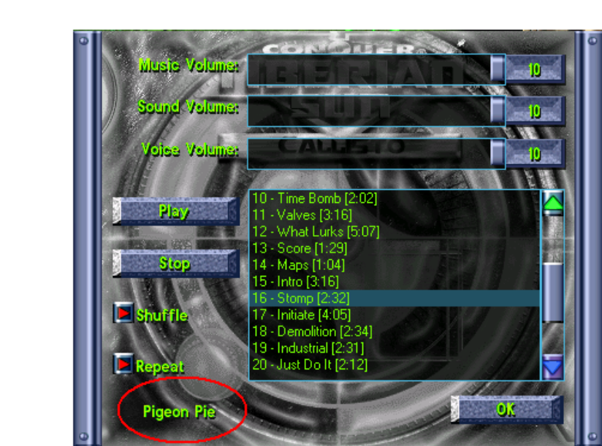

And there we have it. You can do the same for pretty much every dialog box in the game.

Note: TShyper has told me that (in his words):

“Sometimes if a dialog box does not read your new object, it’s because it has to be -1 in the ID box (i think this is because if you add too many things or there are too many things)”

I think he means the help ID box, and if something doesn’t work try putting -1 in it. As this has never happened to me before I cannot say, but I am trying to find out.

“String Table”:

Now for the other folder – String Table. This is where all the other text is kept.
This is for things like the “Game over” message you get when you lose at skirmish, the loading screen text (see pictutre below), the colour list (see the sections on changing the colour list) , the superweapon text (ready, charging, online etc…), the slider text (fastest, slowest, high, low, easy, hard etc…) and more.
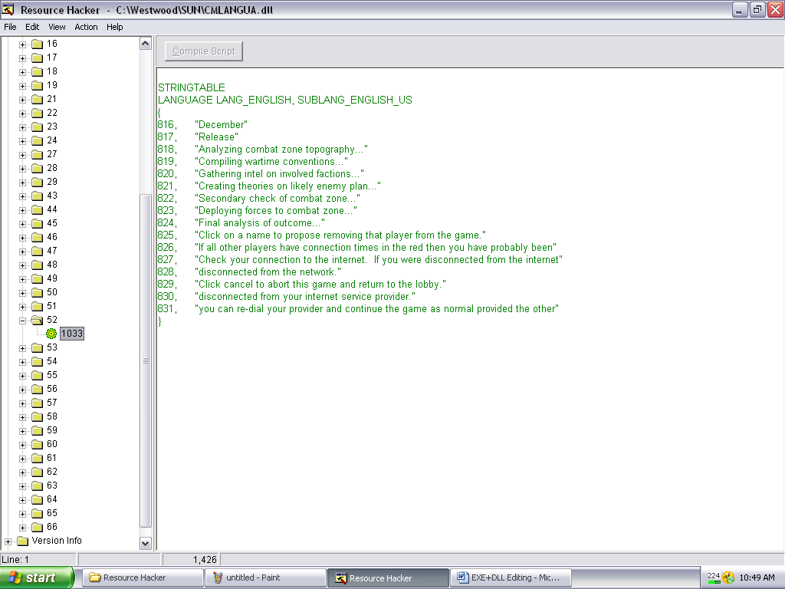

This is very easy to edit, just change the text in between the “” Symbols and save to edit. DON’T change any of the numbers.

The folders “Version Info” and “240” are not that useful really. One is full of undistinguishable blab; the other has information about who made the file in it.

Changing the text and colours in the “select colour” menu (II):
Continuing in our quest for making the new side colour, we now have to change the words so they say “Brown”, rather than “Sky Blue”.

Open “String Table”, and open folder 54.
Then change the text in the data from “sky blue” to whatever you want. Press compile, save and there you go:
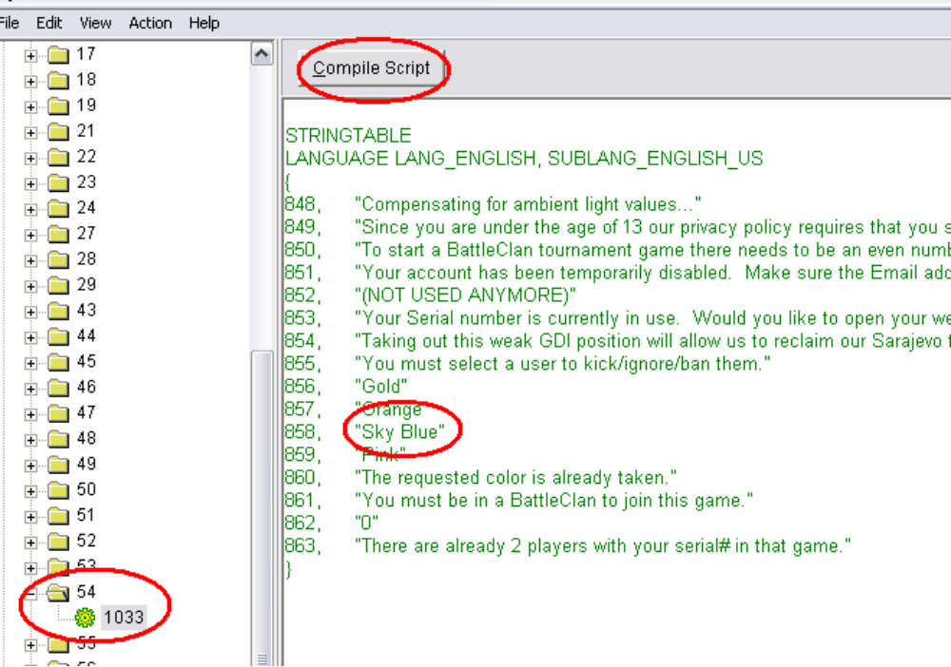
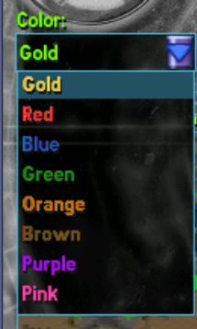
Notice only the colours gold, orange and sky blue are the only ones that appear there. The rest are found in file 44, along with some other stuff. And that’s that. Combined with your rules coding, you have a fully working new side colour.

Changing the error message to one that shows the debug file (I):
This is pretty useless really, as the debug file can be accessed anyway, and when you do access it, it doesn’t help. But it looks pretty.
It is possible as the code is already there. In dialog>222 there is an error message. Copy all the code, and paste it over (replace) the code in 247 (the old message).

Press compile. You will notice an error:
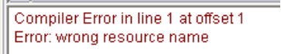
So, change the resource name (number) in the stuff you just pasted from 222 to 247 to match the folder its now in.
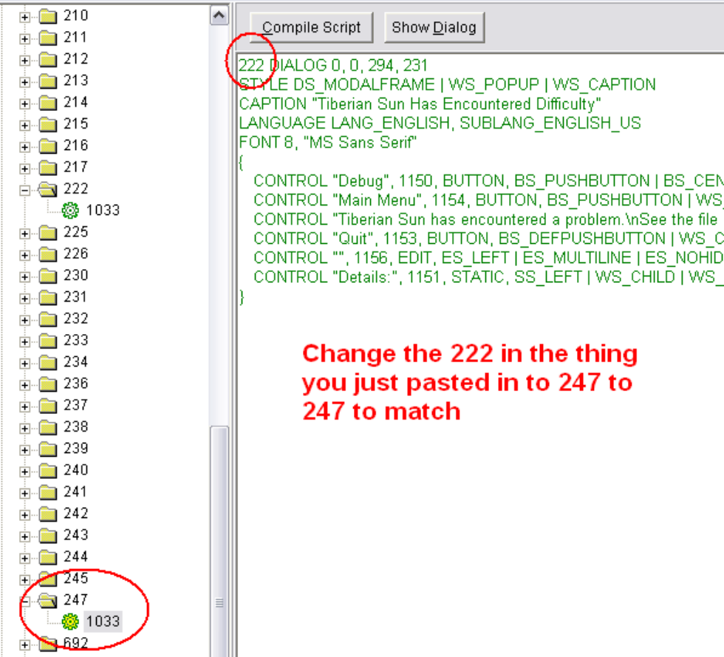

But that isn’t all you have to do. For the next bit you have to move on to:

Section IV – Editing the exe with Resource hacker

Changing the error message to one that shows the debug file (II):

Open your exe with resource hacker after copying the code from your newly made 247 dialog in resource hacker. Click dialog – and open the familiar folder 247. Paste your text in, and save.

BUT before you get too please with yourself – the two buttons in that dialog box saying “Debug” and “Main menu” don’t work. So you have to delete them (easy enough just select the button and press delete on your keyboard). Make the working one (Quit) bigger/centred to stop it looking odd, and there you go. Perfect. You can customise it however you like then, by changing what the text says etc… and achieve a good error message.

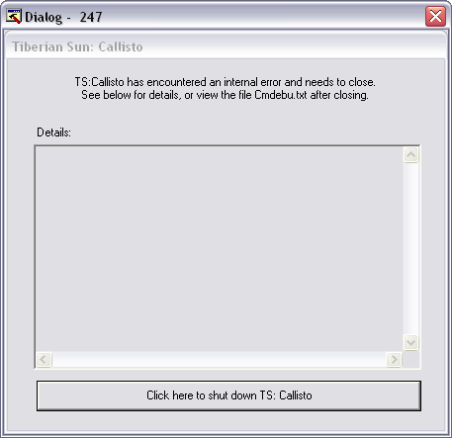

Note: To change the Message that the top bar, edit this part:
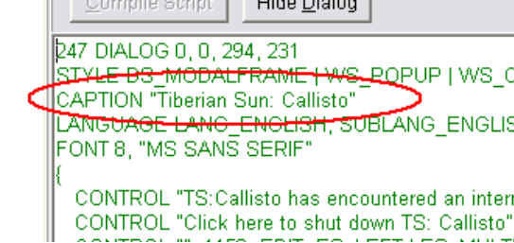

Also, notice the references to font and font size? They can be changed too.

Changing the cursor/Icon:

Easy as pie. Open the folder “Cursor” or “Icon”. Right click the cursor/Icon you want to replace, and click “replace resource”. Select which cursor/icon to replace then click “select file with new cursor/Icon”. Select your cursor/icon and press OK. Save and there you have it.

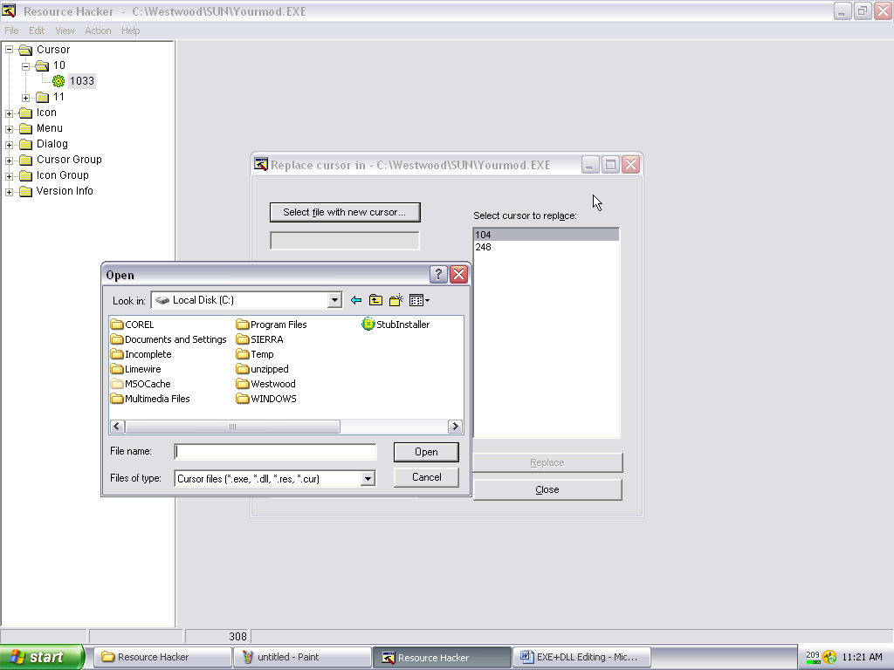

More to come?
Maybe. If I decide to add something to this tutorial or someone points out that I’ve done something wrong a new version will be uploaded. I will make a note of what has been updated if I do this, so you know if you have the latest version.

Any questions? Don’t hesitate to ask. I will be glad to help you.

Thing being worked on:
Possibly a section explaining how to fix the exe when it goes wrong because of adding too much data. But I need to work it out myself first.

